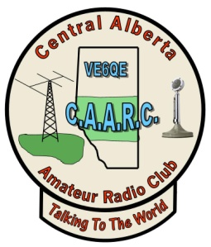
Central Alberta Amateur Radio Club
Membership Application/Renewal

Date:

Legal Name:
(as printed in your amateur license and on RAC/Industry Canada license database)

Call sign: Preferred Name:
(as used on air)
Street Address:
Mailing Address (if different from street):
City: Province: Postal Code:
Home Phone: Cell:
Email:
Are you a RAC Member(Yes or No) ____ RAC Membership Number: _________

⁭ Single membership $25.00
⁭ Family membership $30.00
Family call signs , , , ,
⁭ Repeater and infrastructure donation
⁭ Color membership badge $12
Total submitted

Freedom of information & Privacy Act
Please indicate whether your information may be published in newsletters, callout lists or other lists posted for amateur radio purposes.
Yes No

Signature:

